|  |  |
| --- | --- |
| **COHESION** | **COUPLING** |
| Cohesion is the concept of intra module. | Coupling is the concept of inter module. |
| Cohesion represents the relationship within module. | Coupling represents the relationships between modules. |
| Increasing in cohesion is good for software. | Increasing in coupling is avoided for software. |
| Cohesion represents the functional strength of modules. | Coupling represents the independence among modules. |
| Highly cohesive gives the best software. | Where as loosely coupling gives the best software. |
| In cohesion, module focuses on the single thing. | In coupling, modules are connected to the other modules. |

**Cohesion:**  
Cohesion is the indication of the relationship within module. It is concept of intra-module. Cohesion has many types but usually highly cohesion is good for software.

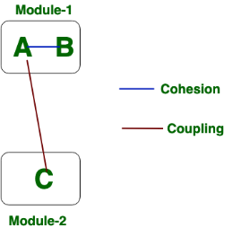**Coupling:**  
Coupling is also the indication of the relationships between modules. It is concept of Inter-module. Coupling has also many types but usually low coupling is good for software.